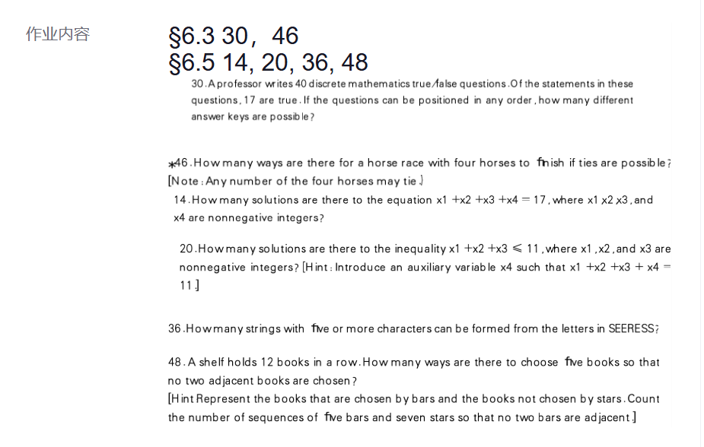
30. A professor writes 40 discrete mathematics true/false questions. Of the statements in these questions, 17 are true. If the questions can be positioned in any order, how many different answer keys are possible?

Solution: C(40, 17) ≈ 8.9 × 1010

∗46. How many ways are there for a horse race with four horses to ﬁnish if ties are possible? [Note: Any number of the four horses may tie.)

Solution:

We can solve this problem by breaking it down into cases depending on the number of ties. There are five cases.

(1) If there are no ties, then there are clearly P(4,4) = 24 possible ways for the horses to finish.

(2) Assume that there are two horses that tie, but the others have distinct finishes. There are C(4,2) = 6 ways to choose the horses to be tied; then there are P (3, 3) = 6 ways to determine the order of finish for the three groups (the pair and the two single horses). Thus there are 6 · 6 = 36 ways for this to happen.

(3) There might be two groups of two horses that are tied. There are C(4, 2) = 6 ways to choose the winners (and the other two horses are the losers).

(4) There might be a group of three horses all tied. There are C(4,3) = 4 ways to choose which these horses will be, and then two ways for the race to end (the tied horses win or they lose), so there are 4 · 2 = 8 possibilities.

(5) There is only one way for all the horses to tie. Putting this all together,the answer is 24+36+6+8+1=75.
14. How many solutions are there to the equation x1 +x2 +x3 +x4 = 17, where x1,x2,x3, and x4 are nonnegative integers?

Solution: C(4+17−1,17)=C(20,17)=C(20,3)=1140

20. How many solutions are there to the inequality x1 +x2 +x3 ≤ 11, where x1, x2, and x3 are nonnegative integers? [Hint: Introduce an auxiliary variable x4 such that x1 +x2 +x3 + x4 = 11.]

Solution:
We introduce the nonnegative slack variable *x4*, and our problem becomes the same as the problem of counting the number of nonnegative integer solutions to *x1 + x2 + x3 + x4* = 11. By Theorem 2 the answer is C (4 + 11 − 1, 11) = C (14, 11) = C (14, 3) = 364 .

36. How many strings with ﬁve or more characters can be formed from the letters in SEERESS?

Solution：
We need to calculate separately, using Theorem 3, the number of strings of length 5, 6, and 7.
(1) There are 7!/(3!3!1!) = 140 strings of length 7.
(2) For strings of length 6, we can omit the R and form 6!/(3!3!) = 20 string; omit an E and form 6!/(3!2!1!) = 60 strings, or omit an S and also form 60 strings. This gives a total of 140 strings of length 6.
(3) For strings of length 5, we can omit two E’s or two S’s, each giving 5!/(3!1!1!) = 20 strings; we can omit one E and one S (5!/(2!2!1!) = 30 strings); or we can omit the R and either an E or an S (5!/(3!2!) = 10 strings each). This gives a total of 90 strings of length 5.
140+140+90=370
For a grand total of 370 strings of length 5 or greater.

48. A shelf holds 12 books in a row. How many ways are there to choose ﬁve books so that no two adjacent books are chosen?
[Hint:Represent the books that are chosen by bars and the books not chosen by stars. Count the number of sequences of ﬁve bars and seven stars so that no two bars are adjacent.]

Solution:
There are 5 bars (chosen books), and therefore there are 6 places where the 7 stars (nonchosen books) can fit (before the first bar, between the first and second bars, ..., after the fifth bar). Each of the second through fifth of these slots must have at least one star in it, so that adjacent books are not chosen. Once we have placed these 4 stars, there are 3 stars left to be placed in 6 slots. The number of ways to do this is therefore C(6+3−1,3)=C(8,3)=56.

